* Experience with app (those who has experience with the app), list down the count each of the limitations **(need to clean the no experience with app data on limitation)**
* Even those who are not injured, still thinks that emergency services are important
* (a graph for this )Topo vs (a graph for this) online map, can put both maps in the app (allows users to switch in between)
* History trail history vs turning on gps

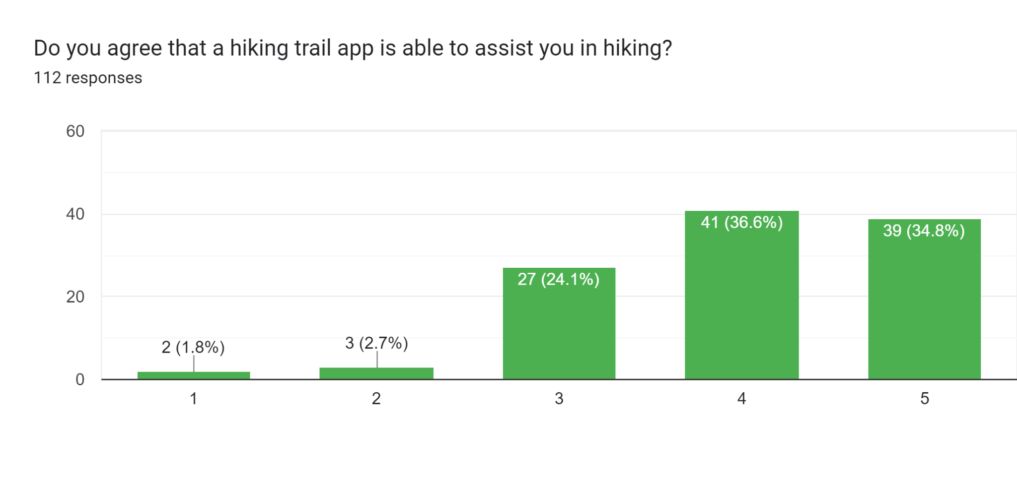

Figure 1: Respondents’ perception on the helpfulness of a hiking trail app

Our survey results, as illustrated in Figure 1, demonstrate that the majority of respondents find hiking trail apps useful, with only five out of 112 disagreeing. Figure 2 shows that the top three limitations of such apps are outdated information, lack of detailed maps, and limited community engagement. Using these findings, we plan to develop an app that addresses these key limitations, while also including emergency services, as identified as a necessary feature by our analysis. We also learned that most users prefer online maps over topographic maps, which we will include as an option in our app. Additionally, our analysis of the trade-off between GPS tracing and trail history preservation revealed that most users who want to save their hiking trails are comfortable with GPS tracking. As a result, we will implement a feature to save users' hiking trails using GPS, which will provide greater accuracy.

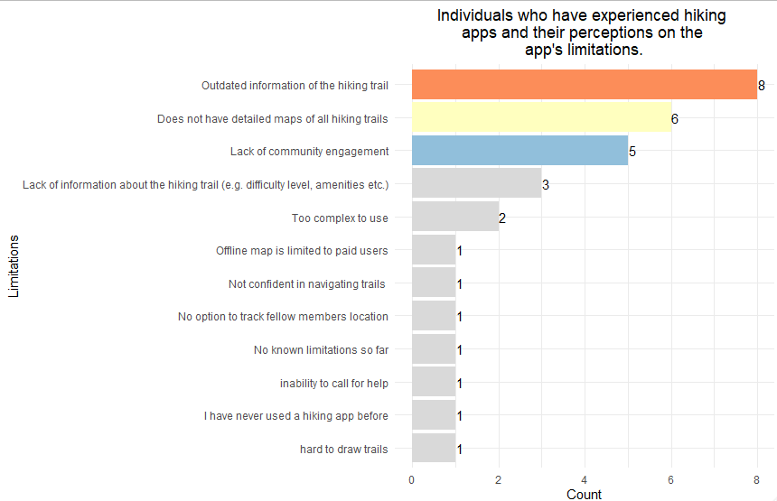

Figure 2: Limitations of those who has experience with hiking apps

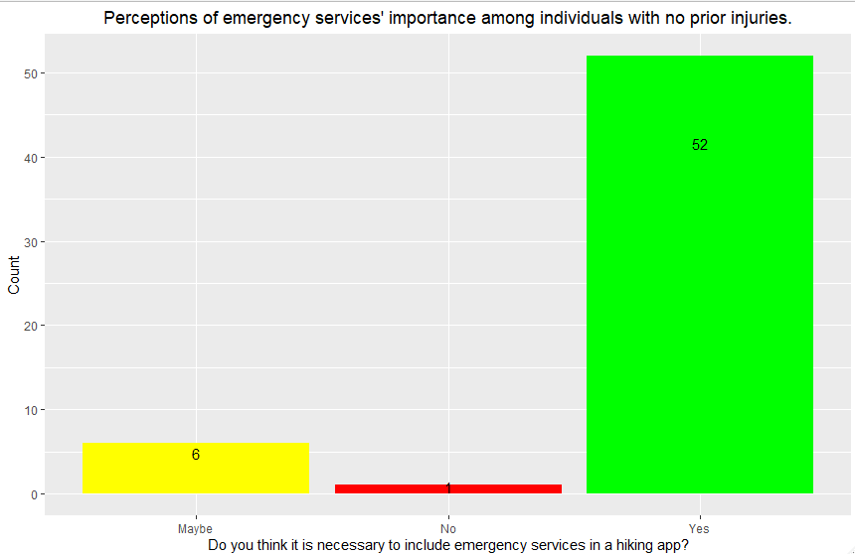

Figure 3: Perceptions of emergency services’ importance among individuals with no prior experience.

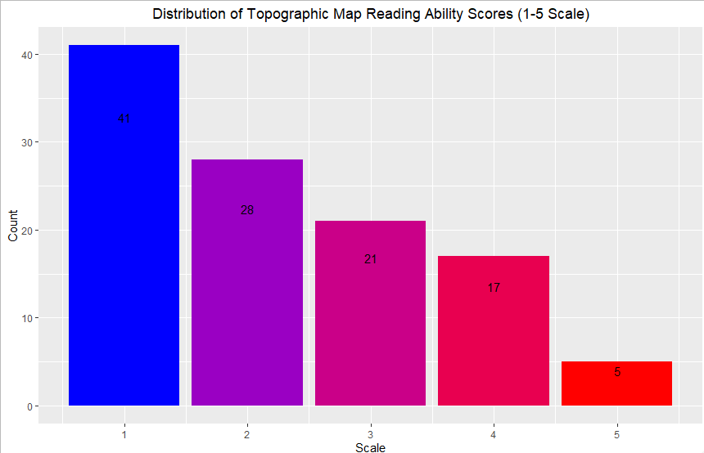

Figure 4: Distribution of Topographic Map Reading Ability Scores (1-5 Scale)

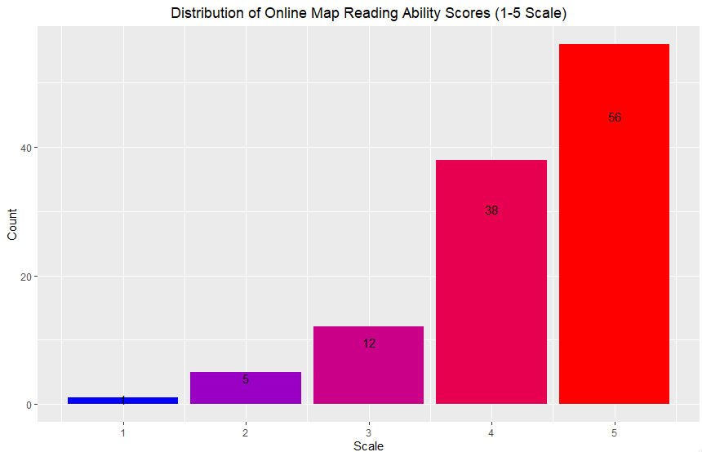

Figure 5: Distribution of Online Map Reading Ability Scores (1-5 Scale)

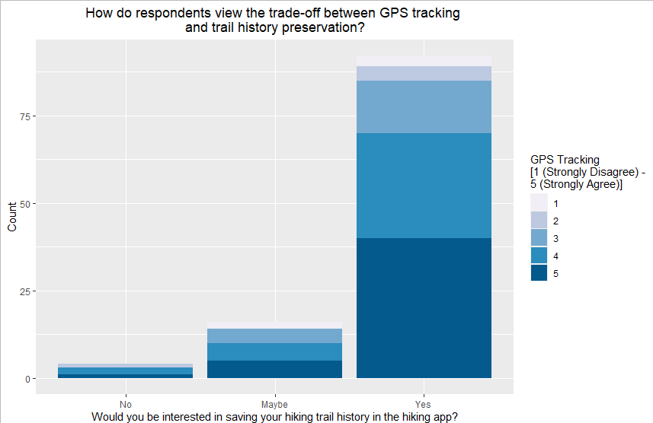Figure 6: Trade-off between GPS tracing and trail history preservation

R code

# FIT3175 Assignment 1

getwd()

setwd("C:/Users/PC/Desktop/FIT 3175/Data")

rm(list = ls())

HikingData <- read.csv('Hiking Trail App Questionnaire - Cleaned Data.csv', header = TRUE)

require(dplyr)

library(dplyr)

HikingAppLimitations <- select(HikingData, c(25:26))

colnames(HikingAppLimitations)

#Filter those who has experience with the app

HikingAppLimitations <- HikingAppLimitations %>% filter(Do.you.have.any.experience.with.hiking.apps. == "Yes")

#don't want the first column

HikingAppLimitations <- select(HikingAppLimitations, c(2))

#Changing the name of the column header

names(HikingAppLimitations)

names(HikingAppLimitations)[1] <- "Limitations"

#split the data

HikingAppLimitations <- separate_rows(HikingAppLimitations, Limitations, sep = ",")

#split a second time just to be sure

require(tidyr)

library(tidyr)

HikingAppLimitations$Limitations <- strsplit(HikingAppLimitations$Limitations, ",")

# unnest the data frame to create new rows for each element

HikingAppLimitations <- unnest(HikingAppLimitations, Limitations)

#Trim the space in front

HikingAppLimitations$Limitations <- trimws(HikingAppLimitations$Limitations, "left")

HikingAppLimitations_Count <- HikingAppLimitations %>%

group_by(Limitations) %>%

summarize(count = n())

# remove row that contains "amenities etc."

HikingAppLimitations_Count <- HikingAppLimitations_Count[!grepl("amenities etc.", HikingAppLimitations_Count$Limitations), ]

#Fixing the data

HikingAppLimitations_Count$Limitations <- sub("Lack of information about the hiking trail \\(e\\.g\\. difficulty level", "Lack of information about the hiking trail (e.g. difficulty level, amenities etc.)", HikingAppLimitations_Count$Limitations)

#HikingAppLimitations_Count[6, 1] <- "Lack of information about the hiking trail (e.g. difficulty level, amenities etc.)"

# library(tibble)

# tb <- as_tibble(HikingAppLimitations_Count)

# tb

library(ggplot2)

HikingAppLimitations_Count <- arrange(HikingAppLimitations_Count, desc(count))

# create a vector of colors for the top 3 bars and "other" bars

top3colors <- c("#ffffbf", "#91bfdb", "#d9d9d9", rep("#fc8d59", nrow(HikingAppLimitations_Count) - 3))

# plot the bar chart with fill color for the top 3 bars

ggplot(HikingAppLimitations_Count, aes(x = reorder(Limitations, count), y = count, fill = ifelse(rank(-count) <= 3, Limitations, "other"))) +

geom_col() +

geom_text(aes(label = count), hjust = -0.1) +

coord_flip() +

scale_fill_manual(values = top3colors, guide = FALSE) +

labs(title = "Individuals who have experienced hiking \napps and their perceptions on the \napp's limitations.", x = "Limitations", y = "Count") +

theme_minimal() +

theme(plot.title = element_text(hjust = 0.5))

"======================================================================================="

HikingAppInjury <- select(HikingData, c(19,28))

names(HikingAppInjury)

names(HikingAppInjury)[1] <- "have_you_been_injured_from_hiking_before"

names(HikingAppInjury)[2] <- "do_you_think_it_is_necessary_to_include_emergency_services_in_a_hiking_app"

#Never injured before

HikingAppNoInjury = HikingAppInjury %>% filter(have_you_been_injured_from_hiking_before == "No injury")

#Never injured before vs include emergency services

df2 <- HikingAppNoInjury%>% group_by(do_you_think_it_is_necessary_to_include_emergency_services_in_a_hiking_app) %>% summarise(COUNT = n())

library(ggplot2)

ggplot(df2, aes(x = do_you_think_it_is_necessary_to_include_emergency_services_in_a_hiking_app, y = COUNT, fill = do_you_think_it_is_necessary_to_include_emergency_services_in_a_hiking_app)) +

geom_bar(stat = "identity") +

geom_text(aes(label = COUNT), position = position_stack(vjust = 0.8)) +

labs(x = "Do you think it is necessary to include emergency services in a hiking app?",

y = "Count",

title = "Perceptions of emergency services' importance among individuals with no prior injuries.") +

scale_fill_manual(values = c("yellow", "red", "green")) + guides(fill = FALSE) +

theme(plot.title = element_text(hjust = 0.5))

"======================================================================================="

#Topographic map

HikingAppTopo <- select(HikingData, c(30))

names(HikingAppTopo)

names(HikingAppTopo)[1] <- "how_well_can_you_read_a_topographic_map"

df3 = HikingAppTopo%>% group_by(how_well_can_you_read_a_topographic_map) %>% summarise(COUNT = n())

library(ggplot2)

ggplot(df3, aes(x = how_well_can_you_read_a_topographic_map, y = COUNT, fill = how_well_can_you_read_a_topographic_map)) +

geom_bar(stat = "identity") +

geom_text(aes(label = COUNT), position = position_stack(vjust = 0.8)) +

labs(x = "Scale",

y = "Count",

title = "Distribution of Topographic Map Reading Ability Scores (1-5 Scale)") +

scale_fill_gradient(low = "blue", high = "red") +

theme(plot.title = element_text(hjust = 0.5)) +

guides(fill = FALSE)

#Online map

HikingAppOnline <- select(HikingData, c(31))

names(HikingAppOnline)

names(HikingAppOnline)[1] <- "how_well_can_you_read_an_online_map_using_gps"

df4 = HikingAppOnline%>% group_by(how_well_can_you_read_an_online_map_using_gps) %>% summarise(COUNT = n())

library(ggplot2)

ggplot(df4, aes(x = how_well_can_you_read_an_online_map_using_gps, y = COUNT, fill = how_well_can_you_read_an_online_map_using_gps)) +

geom_bar(stat = "identity") +

geom_text(aes(label = COUNT), position = position_stack(vjust = 0.8)) +

labs(x = "Scale",

y = "Count",

title = "Distribution of Online Map Reading Ability Scores (1-5 Scale)") +

scale_fill_gradient(low = "blue", high = "red") +

theme(plot.title = element_text(hjust = 0.5)) +

guides(fill = FALSE)

"======================================================================================="

HikingAppTrailvsGPS <- select(HikingData, c(29,32))

names(HikingAppTrailvsGPS)

names(HikingAppTrailvsGPS)[1] <- "would_you_be_interested_in_saving_your_hiking_trail_history_in_the_hiking_app"

names(HikingAppTrailvsGPS)[2] <- "will_you_feel_comfortable_turning_on_the_gps_to_track_your_trail_while_hiking"

df5 = rename(count(HikingAppTrailvsGPS,would_you_be_interested_in_saving_your_hiking_trail_history_in_the_hiking_app, will_you_feel_comfortable_turning_on_the_gps_to_track_your_trail_while_hiking), Freq = n)

# Change the order of the levels in the factor variable

df5$would_you_be_interested_in_saving_your_hiking_trail_history_in_the_hiking_app <-

factor(df5$would_you_be_interested_in_saving_your_hiking_trail_history_in_the_hiking_app, levels = c("No", "Maybe", "Yes"))

library(ggplot2)

ggplot(df5, aes(x = would_you_be_interested_in_saving_your_hiking_trail_history_in_the_hiking_app, y = Freq, fill = as.factor(will_you_feel_comfortable_turning_on_the_gps_to_track_your_trail_while_hiking))) +

geom_bar(stat = "identity", position = "stack") +

labs(x = "Would you be interested in saving your hiking trail history in the hiking app?",

y = "Count",

title = "How do respondents view the trade-off between GPS tracking \nand trail history preservation?",

fill = "GPS Tracking \n[1 (Strongly Disagree) - \n5 (Strongly Agree)]") +

scale_fill_manual(values = c("#f1eef6", "#bdc9e1", "#74a9cf", "#2b8cbe", "#045a8d")) +

theme(plot.title = element_text(hjust = 0.5))